**User Guide – Estate and Facilities Management Helpdesk**

**To log a Ticket on the Helpdesk via Invida**

* Enter the link below to access Invida from your work PC or mobile phone: [<https://ljmu.invida.co.uk/simplified/home>](https://ljmu.invida.co.uk/simplified/home)

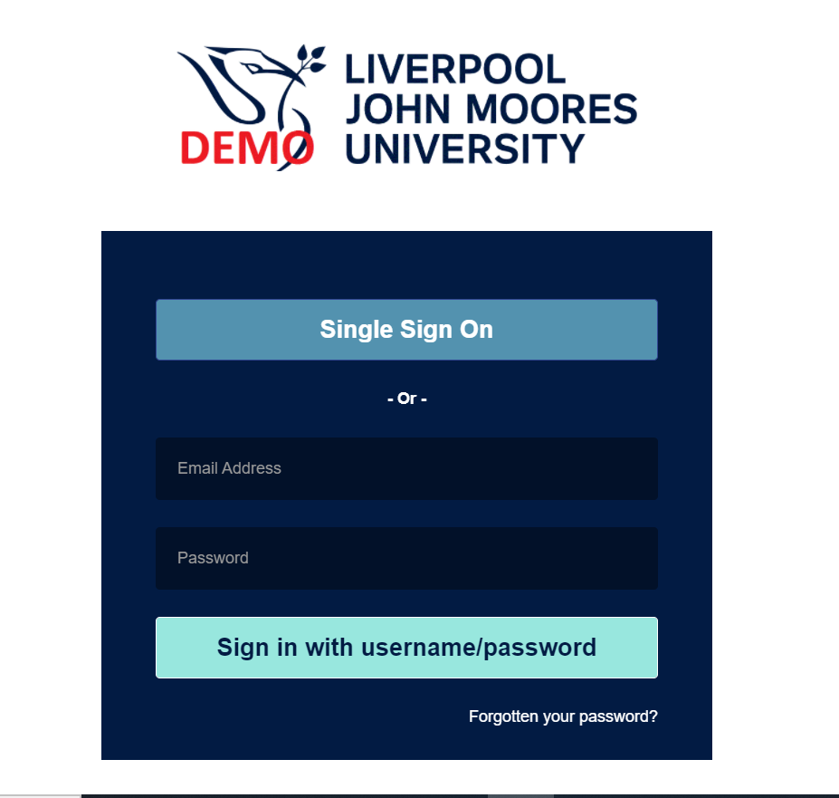

Select ***‘Single Sign On’*** to access Invida.

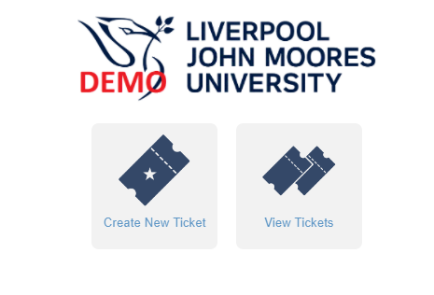

To log a new Ticket, select ***‘Create New Ticket’*** on the Home Page.



Select ***‘Service Request’***

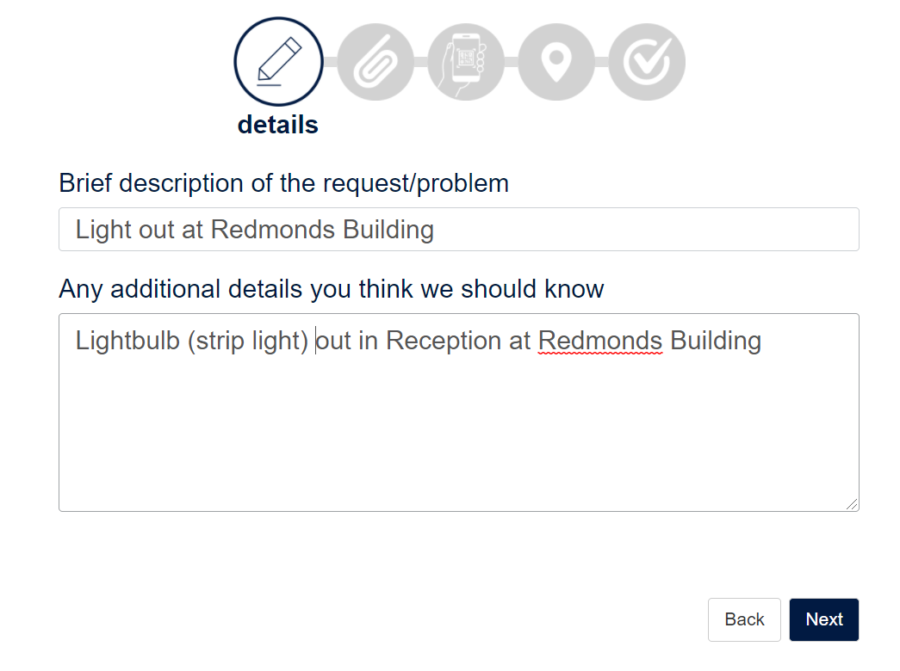

Enter a **brief description** of your request.

Enter any **additional details** – please provide as much detail as possible so the Helpdesk can handle your query at the first point of contact and assign your request to the appropriate Contractor or Team.

Select ***‘Next’*.**

Select *‘Next’*.

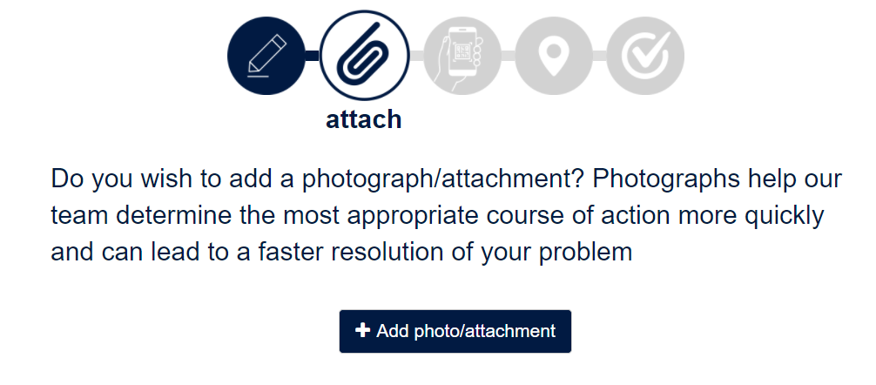

Select ***‘Add photo / attachment’***, if applicable, from your PC or mobile phone.

Select ***‘Next’*.**

You can also skip this section by selecting *‘Next’*.

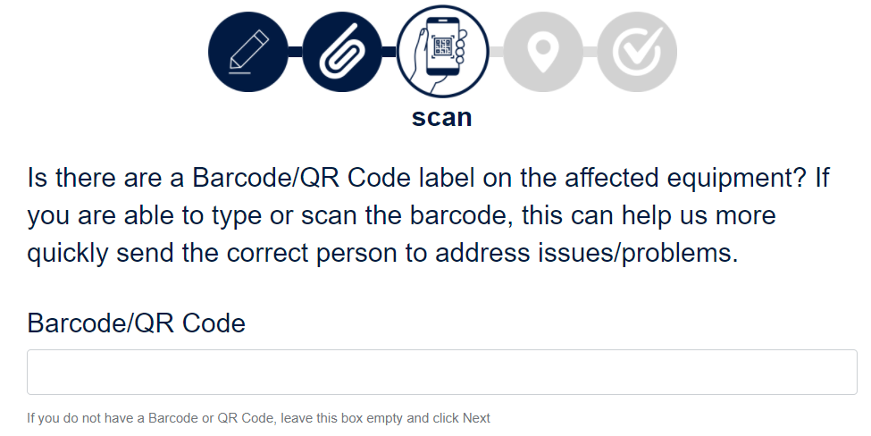

Enter a ***‘Barcode / QR Code’***, if applicable.

Select ***‘Next’*.**

You can also skip this section by selecting *‘Next’*.

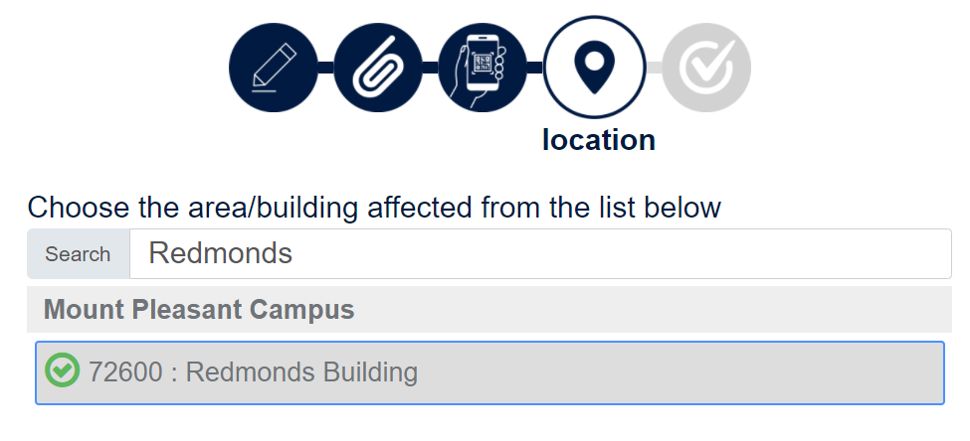

Enter the name of the relevant **building** or select the building from the list.

Select ***‘Next’*.**

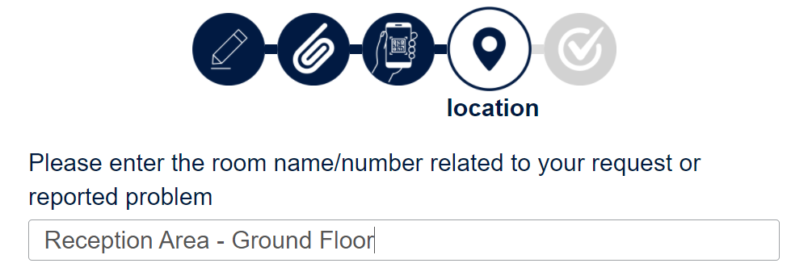

Enter:

* **Room Name / Number**
* **Area**
* **Floor**

Select ***‘Next’*.**

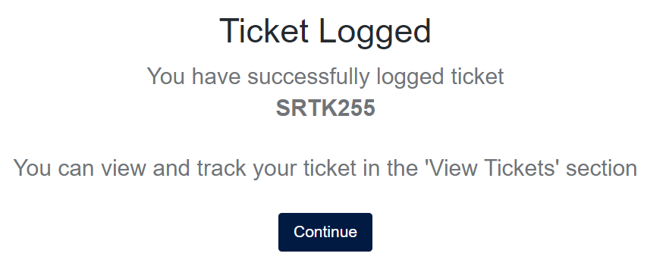

Your Ticket is now logged with the Helpdesk!

You will receive a unique Ticket Number.

Select ***‘Continue’*** to return to the Home Page.

**To View Your Ticket and Ticket History**

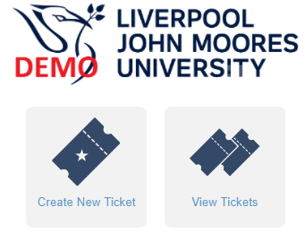

Select ***‘View Tickets’*** on the Home Page to view your ticket history and status of your tickets.

Example:

