How to log an Out of Hours Opening Request
To log an out of hours request, click on this link: - https://ljmu.invida.co.uk/simplified/home

Click “create new ticket “
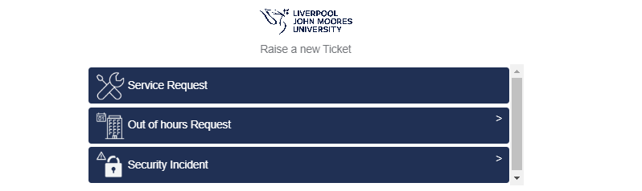

Click on “Out of Hours Request”

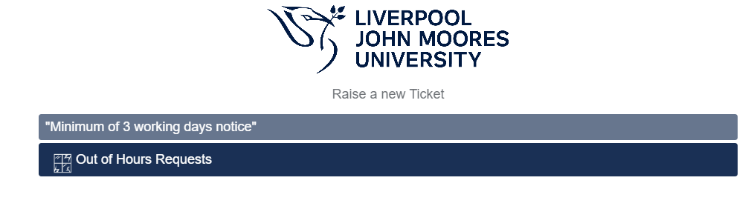Click on “Out of Hours Request”
Please note a minimum of 3 days’ notice is required.

Please provide the reason for the out of hours request i.e., Drama rehearsals/contractors on site

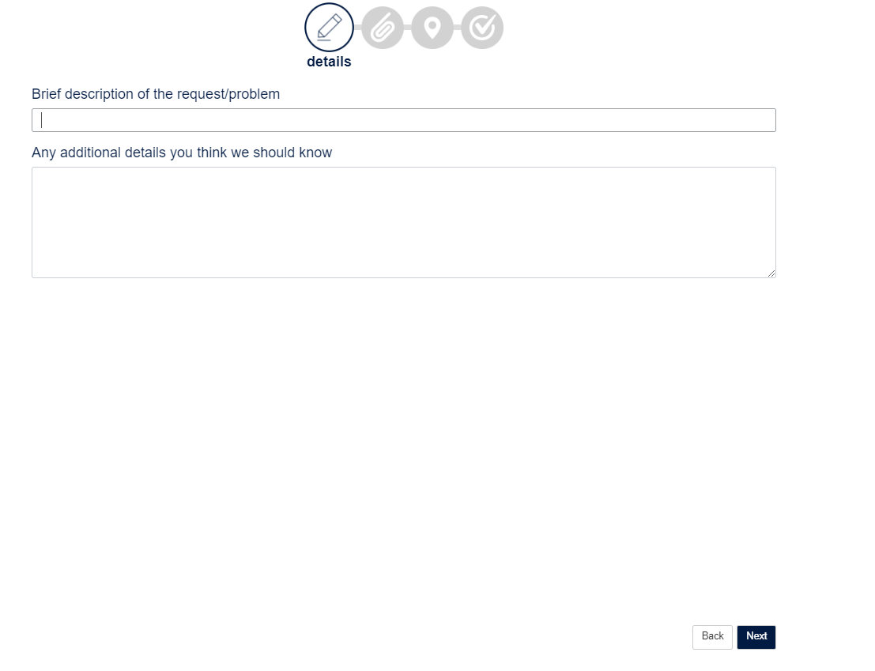
Please supply additional information here i.e., Contractors Names

Please click to proceed to next screen.

NB: - Where possible Student Life Building should be used for out of hours requests before other buildings

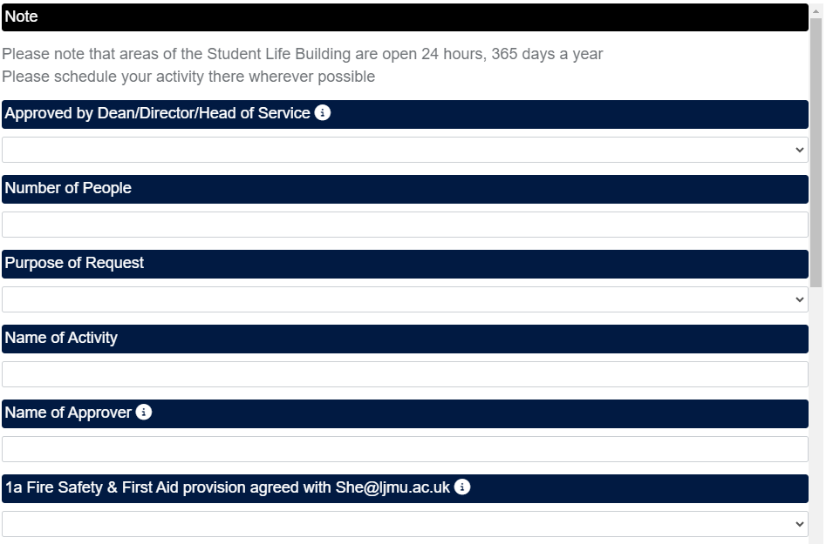
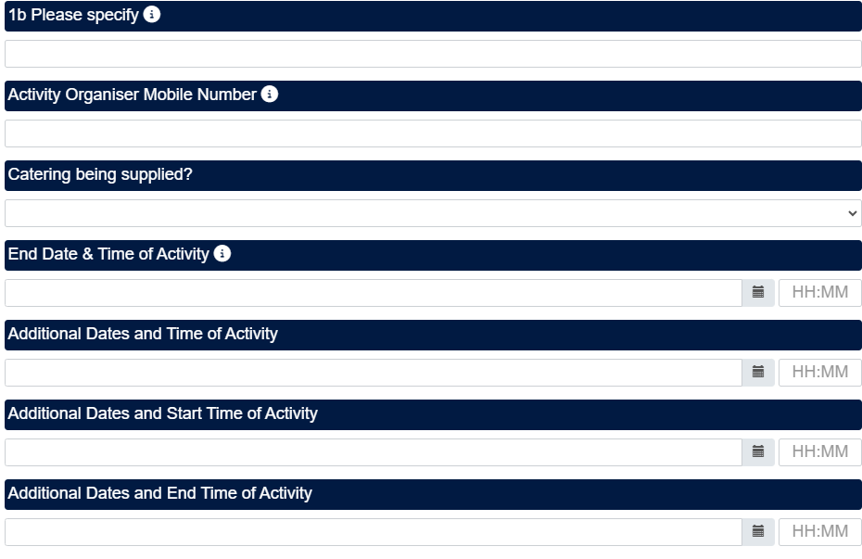
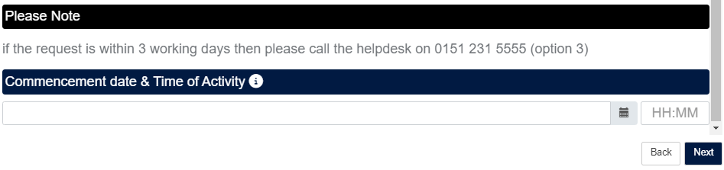
Please click to proceed to next screen.

Please attach room set-ups plans or event information here.

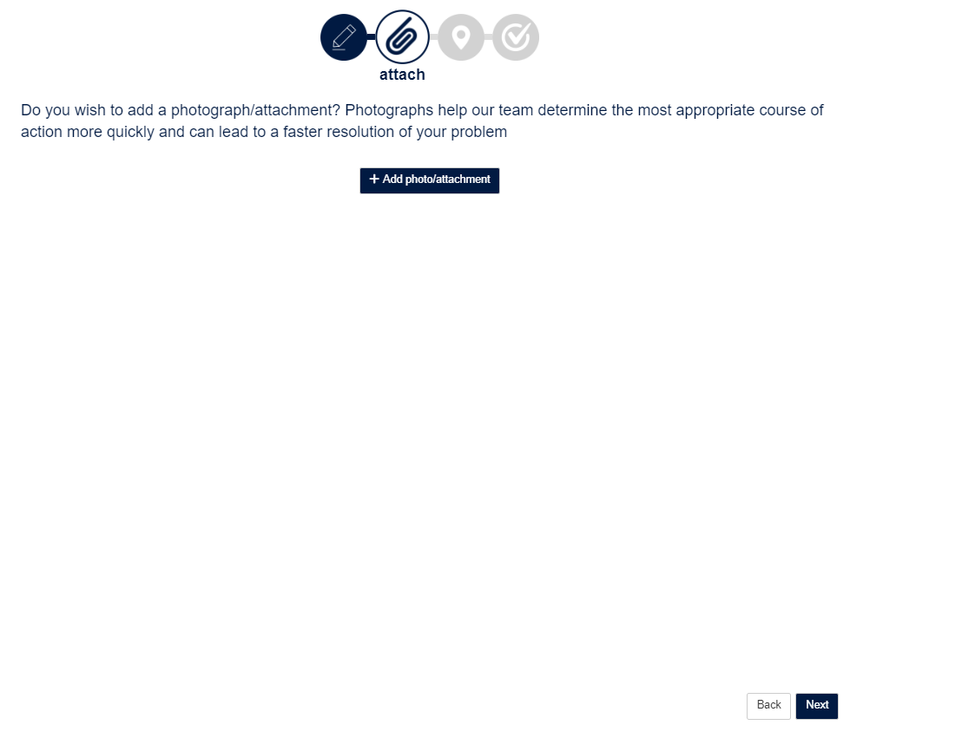
Please click to proceed to next screen.

Please select which Building you require opening.

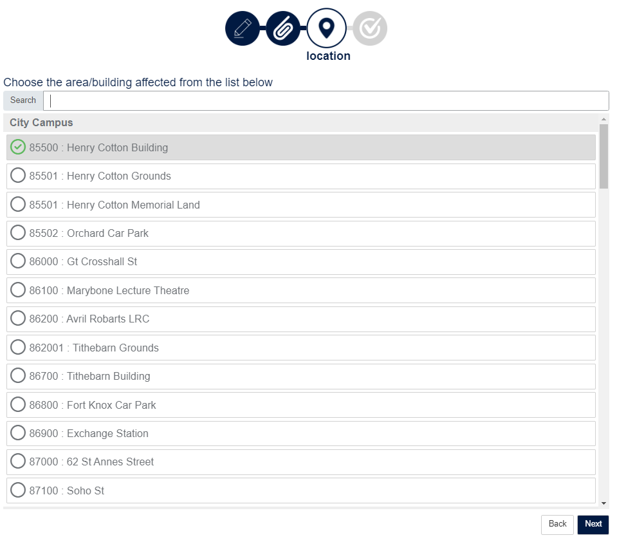

Please click to proceed to next screen.

Please indicate which floor you require if you don’t need access to whole building.

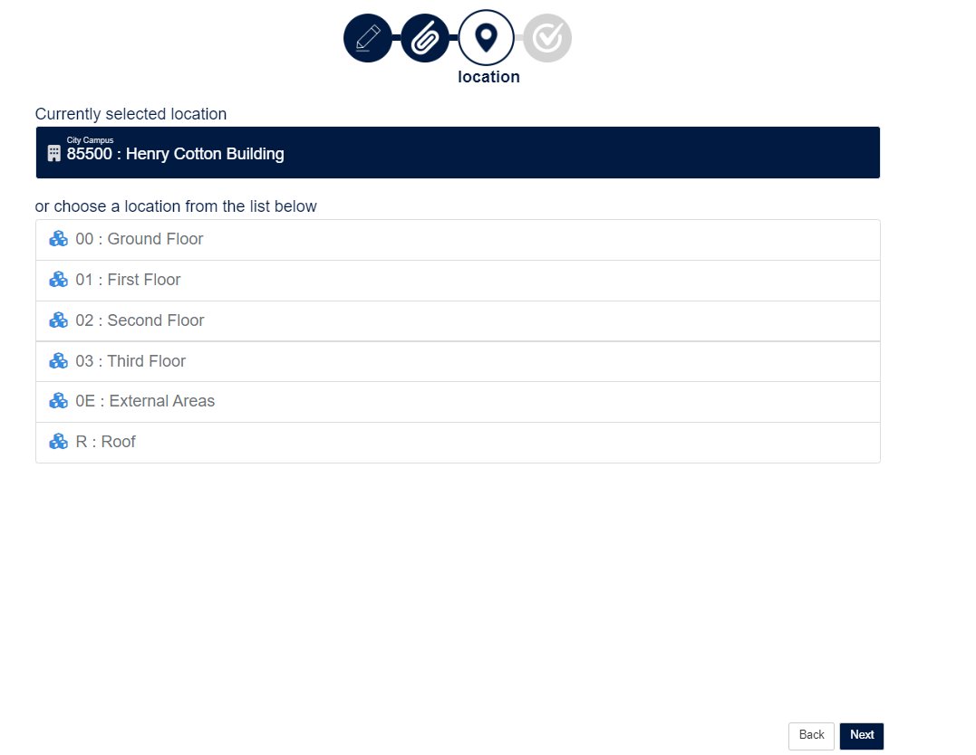

Please click to proceed to next screen.

Confirmation of Location
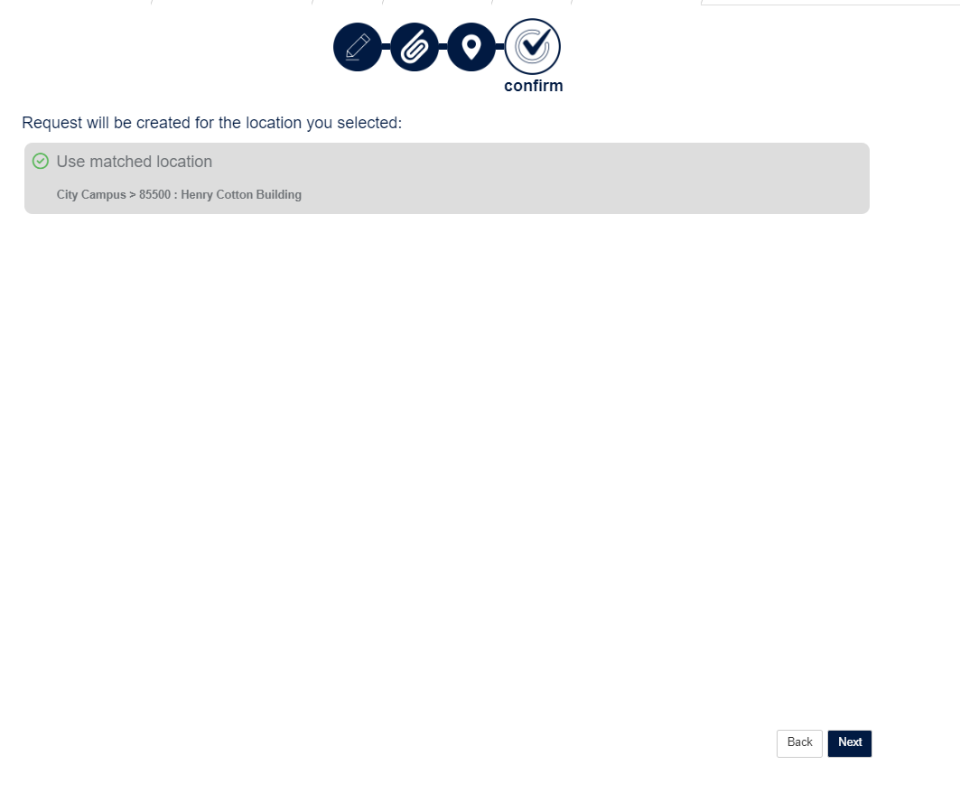
Please click to proceed to next screen if details are correct.

This screen confirms your request has been logged and indicates your ticket number.
